Mule Integration

Architecture Document

Table of Contents

1 Executive Summary 2
2 Integration Overview 3
3 Introduction 3
4 Project Scope 3
5 ESB Foundation Architecture Principles 5
6 SOA Reference Architecture 7
7 High Level Architecture 9
8 Physical Architecture 9
9 Logical Architecture 10
10 Integration Architecture 10
11 Technology Stack 11
10 Clustering and High availability 11
12 Frameworks 12
13 Deployment Considerations 18
14 Continuous Integration & Delivery 18
15 Integration Strategy 19
16 Exception & Error Handling Strategy 25
17 Volumetrics 31
18 Capacity Sizing and Projection 31
19 Canonical Data Model 31
20 Non-Functional Requirements 32
21 Other Architectural Factors 35

Executive Summary
This document is created to provide information about Mulesoft Integration and Design patterns and architecture overview. Document provides more details how effectively we can use Mule ESB in Enterprise Integration Architecture.

MuleSoft offers Mule ESB which is one of famous open source ESB to address the challenges of enterprise integration. According to Mulesoft ,Mule ESB enables over 1,000 organizations in more than 60 countries to build application networks that increase the clockspeed of business. Mule ESB is a trusted middleware platform for many enterprises to build and deliver solutions to complex business problems.

Integration Overview
Organizations need an efficient method to enable system interconnectivity in order to seamlessly provide information and resources to those who need it most, at the right time. To better equip businesses for problem solving, data residing in numerous systems (e.g. legacy, modern, cloud, etc.) must be effectively integrated. Because each system possesses its own data format and protocols, the challenge rests in orchestration between the systems.
Eliminating complicated point-to-point integration allows businesses to stay connected, innovative, and competitive. Moreover, enterprise integration provides businesses the insight to make better decisions
Enterprise integration provides a number of benefits for business:
- System interconnectivity: Connect people, processes, systems, and technologies within your enterprise ecosystem.
- Improved productivity throughout the company: Enable communication across differing systems to permit everyone access to the information they need, anytime.
- The right information when you need it: Provide accurate data regardless of what system you are deploying.
- Real-time updates: Ensure that you are always up to date on your business needs with real-time updates.
- Coordinate business processes: Automate business processes, further improving productivity across your company.

Introduction

Project Objective
<This section explains about the business purpose of the project>

Document Purpose
<This document is intended to capture and convey the significant architectural decisions which have been made in designing and building the system. It is a way by which the systems’ architect and others involved in the project can better understand the problems to be solved and how it will be represented with this system.>

Project Scope
<Describe what is in scope for the project. Also describe or outline what is out of scope for the project and why>

Exclusions
<Delineate specific activities, capabilities, and items that are out of scope for the project>

Assumptions
<Describe any assumptions or dependencies regarding the system and its use>

Risks
<Document specific risks that have been identified or that should be considered.>

Terminology & Abbreviations
<List and describe any terminology used in this document, including any acronyms that have been used>

ESB Foundation Architecture Principles
The architecture should leverage established industry standards and standards based interfaces to ensure maximum reuse across Enterprise
Standard Data and Message Model
While the platform may interact with heterogeneous systems having multiple standards, there has to be a common standard for messages and data within the platform to insulate itself from changes triggered by external systems.

Enable Customisation
The architecture should have maximum configurability to enable the platform to be implemented for various customers mostly by means of configuration changes.

Support for Non-standard Features
The architecture should enable be-spoke custom services to be plugged-in at points where Enterprises typically want to use the platform in a non-standard way. Either sending asynchronous messages or consuming services should achieve this. For these scenarios, the platform should establish service contracts that can be implemented.

Extensibility
While ensuring the current requirements are addressed, the architecture should have provisions to extend itself for future requirements and connecting to other channels.

Service Orientation
The platform should realize the required functionality as a set of services. The services should follow basic service design principles in being atomic, stateless and independent. Services will be exposed whenever:
- There is an interaction between Enterprise internal and external systems
- A capability is identified as the candidate that has usage in more than one application content.

Scalability
The platform should be able to address additional transactions by adding resources without fundamentally altering the implementation architecture or design.

Availability
The platform should enable high availability and should enable managing independent units without affecting the entire platform. The architecture and design should enable configuration and deployment of the platform without affecting the customer.

Loose Coupling
Loose-coupling enables underlying implementations to be modified without significantly affecting the interfacing applications

Canonical Model
A canonical model enables communication between different data format and intended to reduce costs and standardize on agreed data definitions associated with integrating business systems.

Mule Adaptors
Mule adaptors have been designed to make it easier to connect enterprise applications to the Mule enterprise service bus (ESB) in real time.

The other principles of the architecture are:
- Standard Connectivity approaches to be used to ensure minimum impact on ESB layer in case of future strategic change in legacy applications.
- Reuse, as much as possible. TCS will reuse existing Interfaces whatever extent possible. Especially for Legacy application which may have future retire plans should be reused maximum.
- No business logic may be developed in the ESB.
- Integration between applications and services should only be done using the canonical data model.
- Adding a new field to this data integration model should keep all old interfaces compatible.
- Services public interfaces are managed by the ESB (JMS, web services).
- Communication between the two ESBs is always asynchronous.
- Each service must be developed and testable independently of others.
- Get/receive data directly where practical; providing services vs. interfaces
- Maintain at least the current timeliness and accuracy of Service Level Agreement
- Avoid redundancy of interfaces, consolidate and integrate where practical
- Adhere to established industry patterns, reference architecture standards
- SSL is the default standard for the security protocol
- In case of data encryption, entire message/file must be encrypted.

High Level Architecture
<Provide a high-level overview of how system functionality will be allocated to logical subsystems or components>

Physical Architecture
<Provide layout of your physical environment, topology and Server Names, IP Addresses , Server Model, RAM>

Minimum Hardware Requirement for Mule Runtime
CPU | 2GHz/1 Virtual
RAM | 1 GB
Storage | 4 GB
RAM should be adjusted according to requirements of the size and number of simultaneous messages that applications process.

Based on business requirements Mule Runtime can be load balanced or clustered for high availability. Please refer below URL for high availability options available with Mulesoft.

https://docs.mulesoft.com/mule-user-guide/v/3.8/mule-high-availability-ha-clusters

Logical Architecture
<This section should mention about the physical layout, wiring diagrams etc. which provides high level view of integration landscape>

Integration Architecture

Migration

Data Integration
Engineering near real-time data integration and integrating data set can be achieved by Batch processing and Polling scope with Mulesoft.
Mule has the capability to process messages in batches. It splits the large messages into individual records that are processed asynchronously within batch jobs .
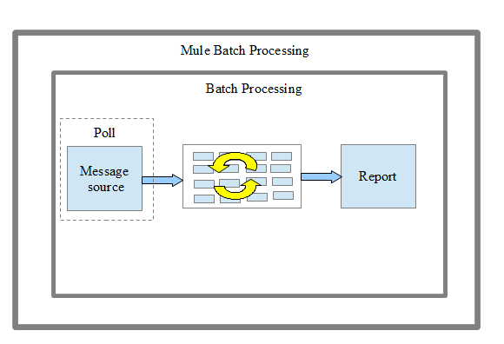
Poll scope in Mule is set up to be 1,000 ms by default to poll the resources for new data. You can change default polling intervals depending on your requirements.
Batch Jobs will process records in phases
Input
It triggers the flow via inbound endpoints and modifies the payload before batch processing (like transform messages).
Load And Dispatch
It works behind the scene, splits the payload into a collection of records, and creates a queue.
Process
It can have one or more batch steps. It synchronously processes the records.
On Complete
It provides a summary report of records processed and helps you get insight into which records fail so that you can properly address the issue. Payload is a BatchJobResult.
It has properties for processing the following statistics:
loadedRecords, processedRecords, successfulRecords, failedRecords, totalRecords.

For the complete details about batch processing please refer below link
https://docs.mulesoft.com/mule-user-guide/v/3.8/batch-processing

Application Integration

Technology Stack
<Provide detailed technical specifications for required infrastructure>

Clustering and High availability
High Availability is a method of designing a computer system to prevent any downtime for the applications that run on it.
The Mule Management Console and Runtime Manager are two ways to set up cluster of Mule instances, then deploy an application to run on the cluster.
A Mule Cluster consists of 2 - 8 Mule server instances, or nodes, grouped together and treated as a single unit.
Mule uses an active-active model to cluster servers .In an active-active model, no one server in the cluster acts as the primary server; all servers in the cluster support the application. This application in this model runs on all the servers
Mule clustering provides High Availability,Throughput,Resource Coordination,Scalability
We can also scale each instance internally to maximize its processing efficiency.
Creation and management of clusters can be done in 3 ways in Mule:
- Using the Mule Management Console’s graphical interface
- Using Runtime Manager
- Manually, using a configuration file

In mule management console approach mule standalone runtime should be configured and mule management console application should be deployed on another runtime. Later mule servers will be registered to management console using mmc agent url(default url http://localhost:7777/mmc-support). Once servers are resgistered then cluster can be created and managed using mule management console.
For more details:
https://docs.mulesoft.com/mule-user-guide/v/3.8/evaluating-mule-high-availability-clusters-demo

In runtime manager approach ,through Runtime Manager, you can register and set up the properties of servers, server groups, and clusters that reside on-premises. Once these are set up, you can select them as the deployment target for your applications.
For more details:
https://docs.mulesoft.com/runtime-manager/managing-servers#create-a-cluster

In Manual cluster configuration, mule-cluster.properties should be created and updated with key-value pair of cluster related properties. Manually created cluster can only managed through manual configuration only
For more details:
https://docs.mulesoft.com/mule-user-guide/v/3.8/creating-and-managing-a-cluster-manually

Frameworks
Framework is an abstraction in which software providing .... Frozen spots define the overall architecture of a software system, that is to say its basic components and the relationships between them.

The main components of Mule ESB are as follows:

Reliability Framework (Integration Services)
This framework will implement Reliability Pattern and will be used in the flows where Reliability is required. This framework will primarily be used for Integration services. Please refer to Reliability Pattern for details.
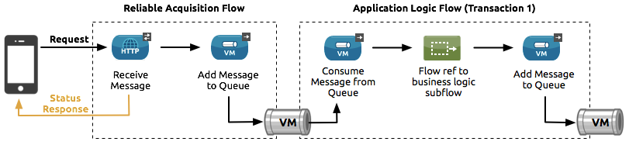

Logging Framework (Migration and Integration Services)
  - Centralized Log Management (CLM) is a type of logging solution system that consolidates all of your log data and pushes it to one central, accessible, and easy-to-use interface.
  - ELK Stack is an open-source centralized logging solution and centralized logging solution is also provided by AWS,, Spulnk , Gray Log2 etc..
  - Logging of all the steps is required.
  - Reliable, Non-intrusive asynchronous logging to queue. Use of async flows.
  - Logging of number of functional entities processed per transaction/ batch processing to be captured.
  - Data to be added to the log message to be fetched from data model.
  - Failure records are required to be logged for root cause analysis
  - Incase of physical queues not available then this framework should be able to continue to log in the files. Once physical queues are up then framework should be able to continue sending logs to it.

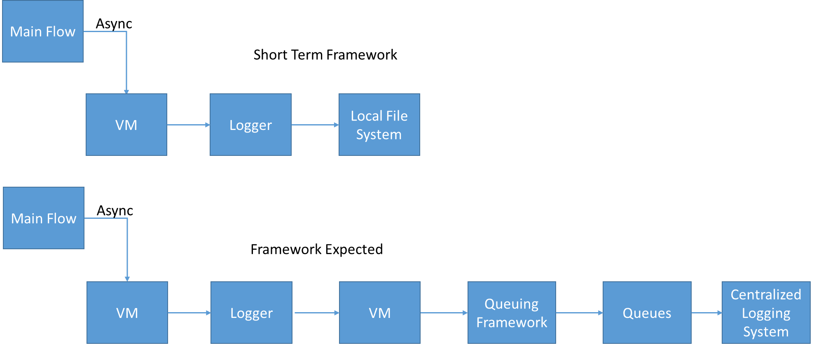

Auditing Framework
- Auditing of events is required at endpoints level.
- Events need to be logged and sent to a queue. Use of async flows.
- Reliable, Non-intrusive asynchronous auditing.
- Incase of physical queues not available then this framework should be able to continue to log in the files. Once physical queues are up then framework should be able to continue sending logs to it.
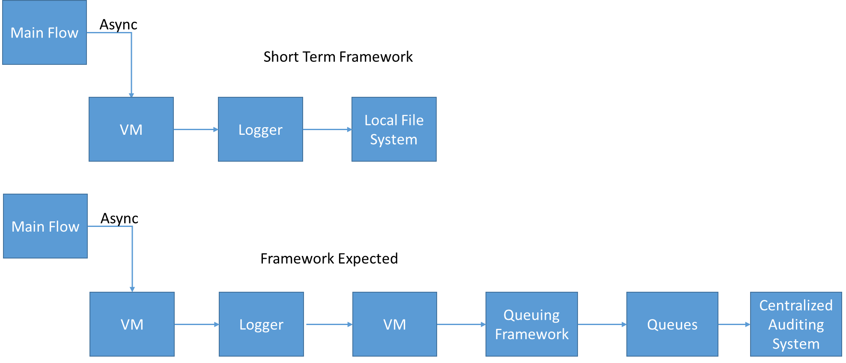

Error Handling Framework
This will be a Global Error Handler which will catch any errors. Logging of the errors will be done to a queue and will follow logging framework specifications. Failure records/ data sets are also required to be logged for root cause analysis. Incase of physical queues not available then this framework should be able to continue to log in the files. Once physical queues are up then framework should be able to continue sending logs to it.

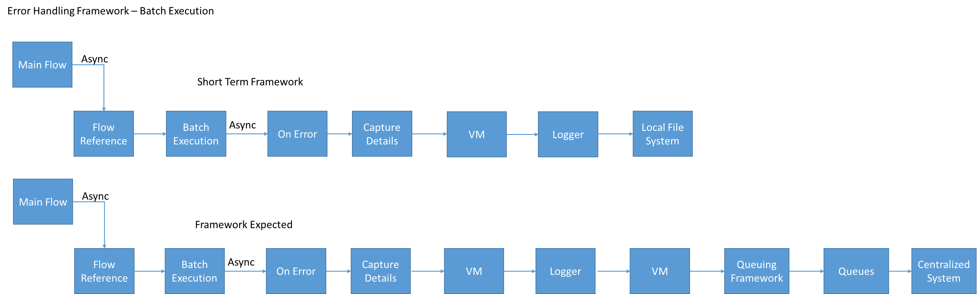

Caching & Lookup Framework
- Caching Strategy
    - Early Loading Framework
During the load time of the application, application on load services will used to get cache data from one or more source systems and populate the database cache (mysql) and the in memory cache.
    - Lazy Loading Framework
During the transaction executions, cached data will be referenced by multiple transactions. In case where the cached data is not found, it will be referenced from database cache and populated in the memory. In case the cached object is not found in database cache also, then the source system (s) will be referenced to get the cache object to populate database cache and in memory cache.
Caching strategy includes caching data in MY SQL Database for Database Cache/ backup copy and avoid lookups to source systems. Cache Scope – Out of box will be used for caching.
- Cache refresh mechanism
Cache refresh Service will work in publish – subscribe model where all the applications using caching will subscribe to publisher service – (queue). When a refresh service is called, a message will be dropped in a queue which will trigger cache refresh for in memory cache and mysql database. This will provide 2 capabilities – Selective Cache Refresh and Refresh All*.
*Refresh All service is expected to be rarely used in case of data issues.
- Cache Eviction Policy (Configurable)
Cache eviction policy keeps optimal cache usage and it will maintain following policies: -
- Least used object
- Expiration – This will be expiration of the cached items
- Cap size – This will be a configurable parameter and will be set to what is maximum allowed by CloudHub (Similar to Object Stores).
- Refresh Cache Policy – This policy is there will be rules where Refresh All service will be invoked to refresh all the cache. Rules can be based on time or based on period of inactivity.
Cache eviction will only evict objects from in memory cache and not mysql database. For clearing of mysql database Refresh Mechanism is required to be used.
Lookup will include: -
- Database Cache Lookup
- Value Mapping
- Value Tree
- SAP Lookup
- For fetching data to be cached
- In Memory Cache Lookup
Incase of database is not available then this framework should be able to continue to cache in the memory. Once database is up then framework should be able to continue using the database.

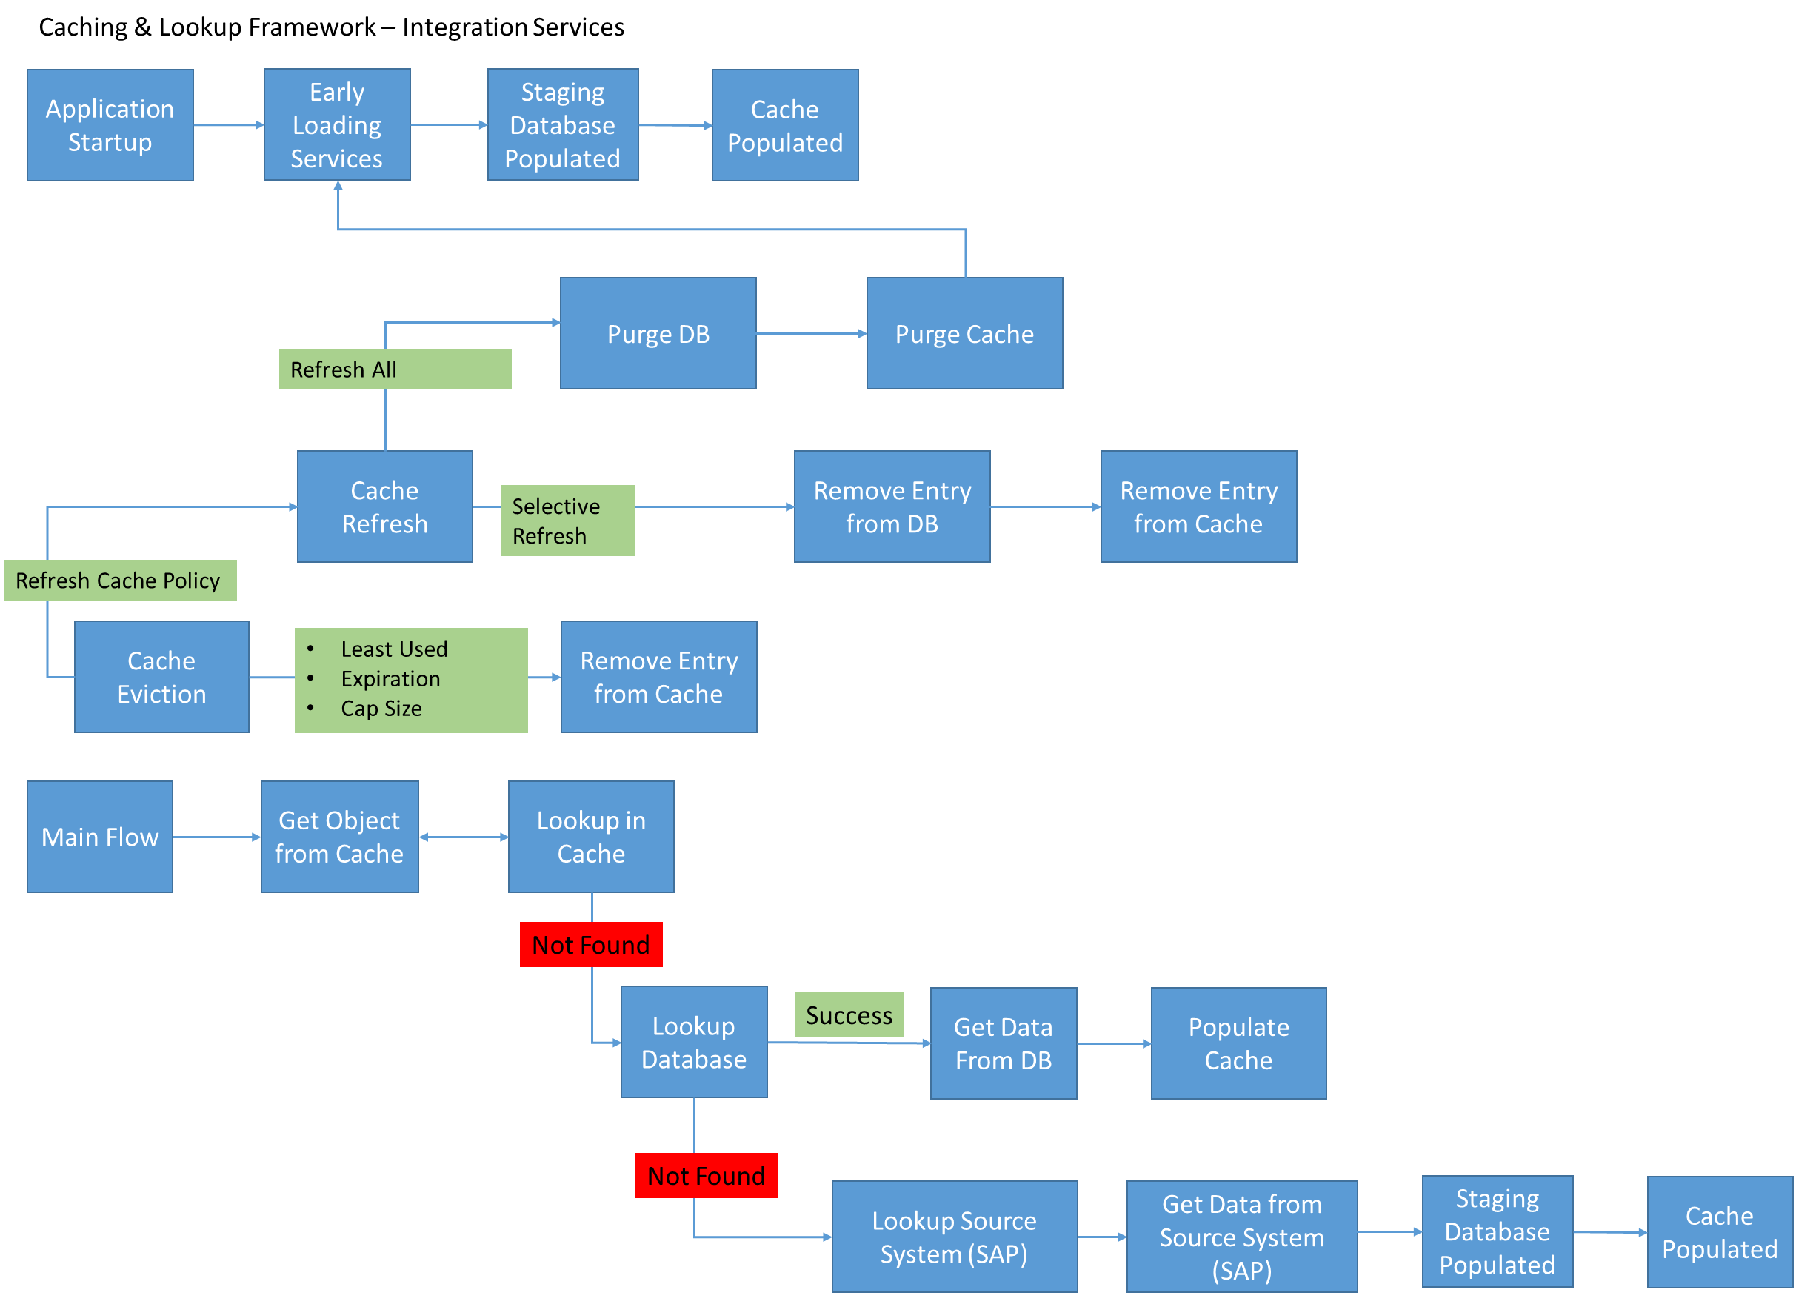

Config Framework
This framework will be responsible for maintaining all the configurations of the connectors and initializations.

Retry Processing Framework
Retry transaction after {config} time for (config) periods then send it to a queue. CheckAvailability service is triggered to keep on checking the availability of target system per (config) secs. Further transactions are also queued up (without retry) when CheckAvailability is on. Once system up and CheckAvailability comes back true continuously for {config} seconds (Stability criteria) then process messages from the queue using batch ({config}).
Design Consideration: Ordering & interdependency of the messages needs to be preserved and processed accordingly.
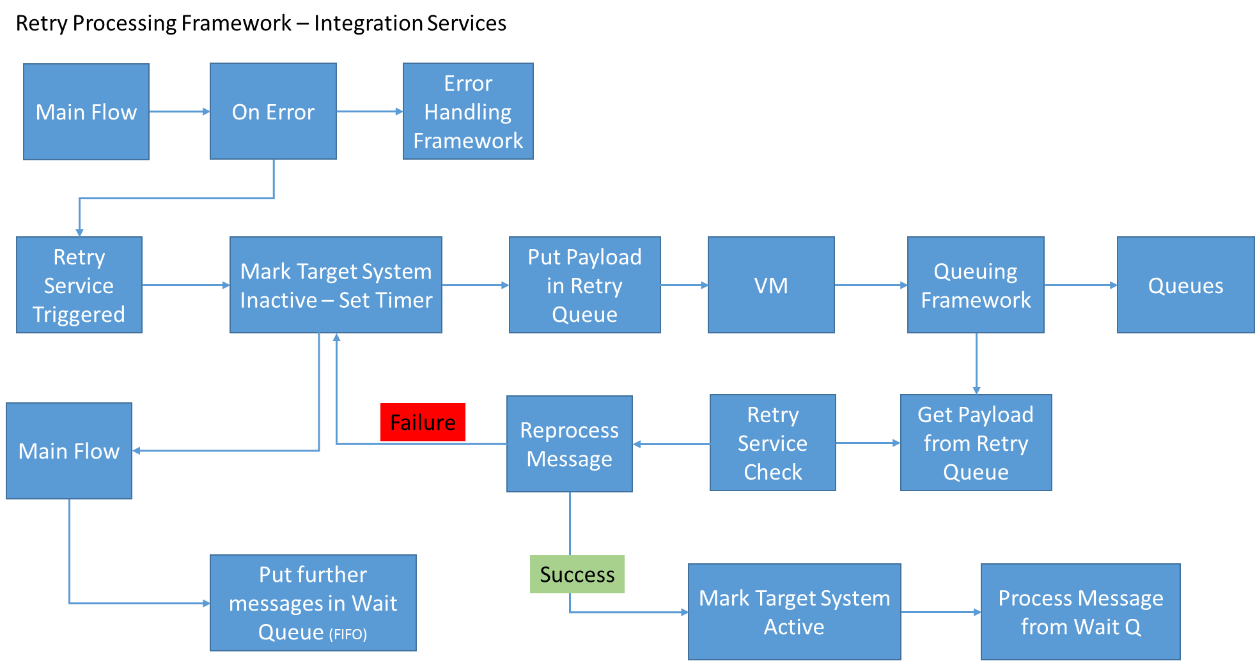

Queuing Framework (Configurable)
Reliability of Messages is currently a major concern. Recommended use of a Physical Queue.
Design Consideration: Need to have Choice in the flow with selection between Amazon SQS, Active MQ and JMS. This to make transition to either queuing solution seamless – via configuration property change.
Infrastructure setup and Outage Considerations: Persistent and non-persistent queues (with backup queues) need to be setup. Also the persistence available for queues will be driving factor for Outage readiness and recovery to be resilient.
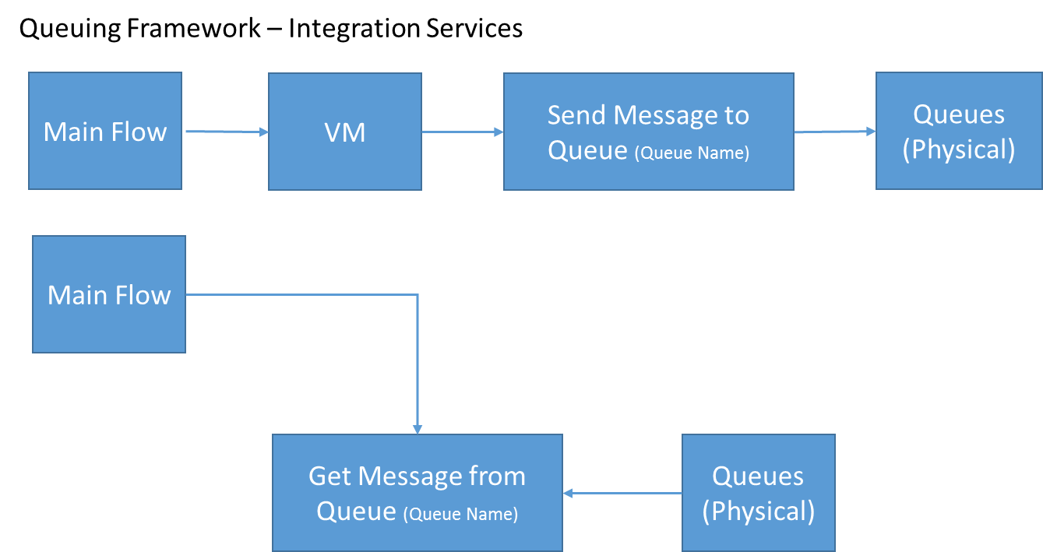

Incase of physical queues not available then this framework should be able to switch to persistent VM queues. Once physical queues are up then framework should be able to switch back to physical queues.

Deployment Considerations
<Provides information on how to design a deployment for performance, security, availability and other system qualities>.

Continuous Integration & Delivery
<This section provides the practices of continuous integration and continuous delivery>
Continuous Delivery is a process that merges Continuous Integration with automated deployment, test and release; creating a Continuous Delivery Solution. Mulesoft provides well set of CI/CD capabilities and can be integrated easily with available open source CI/CD tools and centralized logging framework.

Code Review/Quality Analysis Tool
Test Automation
Version control
Enabling CICD for Mule ESB & API
Continuous Integration & Verification
Monitoring/Analytics
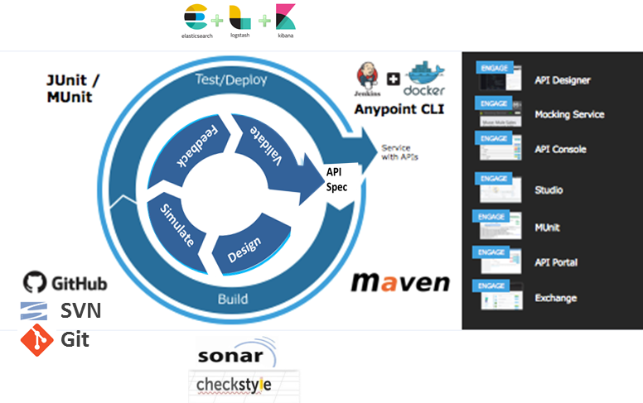


Continuous Analysis / Planning
Dependencies management/ Build automation
API Designer
Mocking Service
API Console
Anypoint Exchange
Anypoint Studio
Munit
Exchange
API Portal

Build Automation | Test Automation | Version Control | Deployment Automation
Describe how a Mule application is assembled.  - Connector configurations  - DB configurations  - Test configuration  Automate that build process every time a change is made to the application | Visually compose tests while or BEFORE you code (Test Driven Development; TDD)  Test with mocked data, not active connections  Validate unit or application functionality | Reliably download(pull), change & commit code  Get instant visibility into incompatible changes  Enables parallel team development | Describe how a Mule application is deployed  - Schedulling  - Environment configurations  - Test/success criteria  Automate that deployment across teams, projects and environments

MAVEN JUNIT/MUNIT GITHUB JENKINS

- Setting up a maven project in Anypoint Studio [Build Automation]
- Creating automated tests with MUnit and Junit [Test Automation]
- Connecting Mule projects with a SVN/GitHub repository [Version Control]
- Deploying Mule applications automatically with Jenkins [Deployment Automation]

Integration Strategy
This section details the integration approaches and the patterns that are required. All of the points may or may not be applicable for all Enterprises. It is during the design phase each of the approach and patterns applicable are required to be applied.
Following is a High level Integration Strategy flow: -

Integration Approaches
There can be several ways in which applications can be integrated. These options can be categorized as follows:
S. No. | Approach | Description | Important Aspects | Implementation Perspective
1 | File Transfer | Applications produce files that contain shared data for others to consume and consume files that others have produced | - Filename, location, format of file  - Timing of file read & write  - Deletion & archive after processing | - Managed File Transfer using ESB  - Scheduler
2 | Shared Database | Applications store data they wish to share in a common database | - No duplication of data & no data transfer | - JDBC/ODBC (direct database access)
3 | Remote Procedure Invocation | Applications expose some of its procedures so that they can be invoked remotely, and have applications invoked those to initiate behaviour and exchange data | - Real time  - Synchronous | - Web Services  - API
4 | Messaging | Applications connect via a common messaging backbone, exchanging data and invoking behaviour using messages | - Shared common channel for communication  - Asynchronous | - JMS  - Active MQ components
5 | Data Integration | Data is transformed and copied for target applications. | - Bulk data exchange  - Transformation | - Data Transformation
6 | File to Message Transfer | Applications process records in the files at input location and push messages to queues or topics | - Filename, location, format of file  - Timing of file read & write  - Deletion & archive after processing  - Message,Record count | - Managed File Transfer using ESB  - JMS  - Active MQ components
7 | Message to DB | Applications read messages from queues and write to the data base which can be used by other applications too. | - Shared common channel for communication  - No duplicate data  - Asynchronous | - JMS  - Active MQ Components  - DB Access

MuleSoft - Reliability Pattern
A high-reliability application (one that has zero tolerance for message loss) not only requires the underlying ESB to be reliable, but that reliability needs to extend to individual connections. If our application uses a transactional transport such as JMS, VM, or JDBC, reliable messaging is ensured by the built-in support for transactions in the transport. This means, for example, that we can configure a transaction on a JMS inbound endpoint that makes sure messages are only removed from the JMS server when the transaction is committed. By doing this, we ensure that if an error occurs while processing the message, it will still be available for reprocessing.
In other words, the transactional support in these transports ensures that messages are delivered reliably from an inbound endpoint to an outbound endpoint or between processors within a flow. Note though that if we want to move messages between different transports that support transactions we need to use XA transactions to ensure that both transports' transactions are committed as one atomic unit.
However, suppose we have a web application that uses a non-transactional transport such as HTTP. How do we ensure reliable messaging for our application? The answer is to follow a reliability pattern.
Note that VM file persistency is disabled on clusters, so VM endpoints persist in-memory in a clustered topology.
A reliability pattern is a design that results in reliable messaging for an application even if the application receives messages from a non-transactional transport. A reliability pattern couples a reliable acquisition flow with an application logic flow, as shown in the following diagram.

The reliable acquisition flow (that is, the left-hand part of the diagram) delivers a message reliably from an inbound endpoint to an outbound endpoint, even though the inbound endpoint is for a non-transactional transport. The outbound endpoint can be any type of transactional endpoint such as VM or JMS. If the reliable acquisition flow cannot deliver the message, it ensures that the message isn't lost:
- For socket-based transports like HTTP, this means returning an "unsuccessful request" response to the client so that the client can retry the request.
- For resource-based transports like File or FTP, it means not deleting the file, so that it can be reprocessed.
The application logic flow (that is, the right-hand side of the diagram) delivers the message from the inbound endpoint (which uses a transactional transport) to the business logic for the application.

Exception & Error Handling Strategy
Information Logging and Exception Handling services are an integral part of all important applications within an enterprise. Individual applications usually develop their own logging and exception handling capabilities although the underlying concepts and basic requirements of these services are commonly shared by other applications in the enterprise. This practice results in unnecessary redundancy since different applications use different technologies and products to implement the same concepts and functionality. To remove unnecessary redundancy, provide standardization, and save time and costs, a common solution framework for logging and exception handling is necessary.

All possible errors like data errors, data format errors, missing values and data truncation should be captured. Common Exception handling framework can be utilized to store the error details. Exception can be classified in the below categories.
- Missing Input files( If any )
- Corrupt Input Data
- Rejected Records
- Based on Error Logs

High level approach for enterprise exception handling framework are:
- Standardise the Exception and Logging canonical (Recommended)
- Archiving and purging strategy

Standardized Logging & Exception Canonical
First thing to achieve Enterprise Exception handling and logging would be to standardise the message been logged / published for exception and logging / auditing. Some of the generic elements would be mandatory for all applications and some application specific elements can be optional.

Exception schema details
Element | Description | Purpose
ErrorCode | Unique code for an error within the system. One of the error codes enumeration defined as part of the framework | Unique code to identify the exception. Would be helpful for support team
ErrorMessage | Short error message of the actual error | Short error message which gives failure details to all
ErrorDescription | Detailed error message of the actual error | Detailed description of failure used by support team to resolve the exception
ErrorSeverity | Severity of the error. One of the severity enumeration defined as part of the framework | It can be used to automate ticket generation. Like all FATAL severity needs ticket generated
ErrorType | Broad categorization of type of the error. One of the error types enumeration defined as part of the framework | Gives high level idea about exception for understanding and debugging the exception
ErrorCategory | Categorization of the error if it is an internal or external error etc. One of the error categories defined as part of the framework | Distinguishes between Internal business and external business exception
ErrorTimeStamp | Timestamp in UTC when the error happened | Gives time at what time exception occurred
ErrorReplyDestination | Destination JMS queue where the exception handler will reply to
ContextData | Any contextual data set by the exception handler while replying back. It is a name value pair ranging from o to n | Data used while reply
RequestInitiator | Source system for request origination | Helps in debugging / resolution of exception
ServerFQDN | Fully qualified domain name of the server where the error happened | Helps in debugging / resolution of exception
ApplicationName | Name of the Application where the processing failed | Helps in debugging / resolution of exception
ComponentName | Name of the component where the processing failed | Helps in debugging / resolution of exception
ThreadID | Thread Id or process Id where the processing failed and can be tracked to | ProcessID or JobID used for debugging / resolution of exception
StackTrace | Detailed stack trace of the error if available | Helps in debugging / resolution of exception
BusinessID | BusinessID gives tracking ID business would be required to track the failed transaction. This ID would be in Key value format, since every interface would have different business ID for tracking. Like ContractID, ApplicationID | Used to track at message level. It can help business to track the transaction. Helps in bridging the gap between support team and business
CorrelationID | Gives unique ID to track the message | Used to track the message end to end
ErrorSeverityLevel | Gives severity level like 1, 2, 3, 4, 5 | It helps NOC team to decide what action needs to be taken.
UserId | User ID through which source system failure occurred | Helps identify user
ErrorAttributes | This field would be in Key Value format. This attributes help in identifying the error cause – like if error occurred during lookup then we can have the lookup key - value for which error occurred. | Used for debugging – Helps understand exact value for which exception occurred
TransactionID | Unique ID for each transaction | Used for tracking the individual transactions.

Log Event Check List
Category | Events to Log
Security | Security Authentication/Authorization, System Access, Data Access
Changes | System and Application Changes (Privilege Changes), Data Changes (Creation and Destruction of objects)
Threats | Invalid Input (Schema validation Failures)
Exhausted Resources/Capacity | Limits reached (message throughput, replays), mixed availability issues
Startups and Shutdowns | Startups and Shutdowns of systems and services
Fault and errors | Errors, Faults and other application issues

Logging schema details

Element | Description | Purpose
LogFormatVersion | The version of the audit log entry format. If the record format changes, parsers can continue to interpret the fields correctly. This field facilitates future change in the audit log record format while continuing to allow parsers to interpret these fields. | This field facilitates future change in the audit log record format while continuing to allow parsers to interpret these fields.
LogEventTimeStamp | Time in UTC when the event happened | Gives time at what time logging occurred
LogEventCode | Code for a particular type of logging event | Gives what kind of event triggered log
LogEventInformation | Detailed description of the event | Event details
LogLevel | Broad categorization of type of the event. It could be DEBUG/INFO/ERROR | Helps in filtering the logs
LoggingApplicationID | The ApplicationID which is currently logging the information | Helps team in debugging or reporting
LogFileNames | Log file names and location where detailed information can be found | Helps team in debugging
ContextDataAtStart | Context data at the start of a transaction | Helps team in debugging, reporting and Auditing
ContextDataAtEnd | Context data at the end of a transaction | Helps team in debugging, reporting and Auditing
CorrelationID | Gives unique ID to track the message | Used to track the message end to end
UserId | User ID through which source system failure occurred | Helps identify user
SourceRecordCount | Source Record Count for file based data transfer | Helps in reconciling the number of records at source and target
TargetRecordCount | Target Record Count for file based data transfer | Helps in reconciling the number of records at source and target
Status | Indicates the status of application processing | Helps understand status such as Received Order, Processing Order, and Completed.
Audit | Indicates if auditing is required. | When auditing is required, the size of the transaction is calculated.
TransactionID | Unique ID for each transaction | Used for tracking the individual transactions.

Correlation ID
Correlation ID is a unique identifier to track an event or message from end to end processing. In addition to uniqueness, it also provides extra information to help support troubleshooting. Applications can participate in the enterprise logging and exception handling by using a unique Correlation ID. It is recommended that source application must have correlation ID populates within the message. In case source system is not able to populate the correlation Id as a part of message (Predefined Flat file formats) source system and ESB layer has to agree on the logic of generating same based on parameters e.g. file name, directory name , timestamp .

Correlation ID schematic
<hostname or system id>|<executable name>|<thread id or record id>|<timestamp in milliseconds>

The maximum length of the Correlation ID is 100 characters
The Correlation ID components are separated by the “|” (pipe) sign.
- In case of Web Service and JMS, it is recommended to have this value populated at header level.
- In case of Flat files and there is scope of change in file schema, this can be populated as a header record
- In case of flat files and schema is predefined, ESB layer will generate correlation ID.

<hostname or system id>
Uniquely identifies the system where the transaction generated from. It could be a system identifier or the hostname of the process which generates the transaction.
- In case file does not contains the correlation ID, host name will be populated by following ways:
  - Name of the file directory – assumption one directory per application
  - File name must contain the Application Name (host name)

<executable name>
The name of the process, executable that generates the transaction.

- In case file does not contains the correlation ID, executable name will be populated by following ways:
  - Name of the file sub directory – assumption one sub directory per process
  - File name contains the process name and ESB will extract the same

<thread id or record id>
The run time process id or record id/record key that uniquely identifies the transaction inside the source application.
This portion is to augment the <timestamp in milliseconds>to assure uniqueness in case of a multithreaded application.
- In case file does not contains the correlation ID, executable name will be populated by following ways:
  - Mutually agreed unique field in the file or record, In case of multiple records it will be per record
  - File name contains the Timestamp

<timestamp in milliseconds>
Current date converted to milliseconds, e.g. 1323477871296 (Fri Dec 9 16:44:31 PST 2011)

This will be populated by ESB layer when transaction is read by ESB layer.

Note: In exceptional cases, ESB layer will maintain the cross reference of transaction unique id generated by Source system and the correlation ID generated by ESB. This needs further design efforts.

End to End Message Tracking
In the exception canonical model defined above we have following fields –
- Correlation ID - Gives unique ID to track the message. It is generated and added to message from the system which originates the message. This ID remains same for that message and no other application is allowed to change the correlation id.
- BusinessID – Gives tracking required by business. This ID would be in Key value format, since every interface would have different business ID for tracking.
- Application Name - Name of the Application where the processing failed
- ComponentName - Name of the component where the processing failed.
- TransactionID- Unique ID for each transaction
In the logging canonical model defined above we have following fields –
- Correlation ID - Gives unique ID to track the message. It is generated and added to message from the system which originates the message. This ID remains same for that message and no other application is allowed to change the correlation id.
- LoggingApplicationID - The ApplicationID which is currently logging the information
Here we can track the message based on Correlation ID, messages with same Correlation ID and different application ID can give us end – to end tracking of message.

Exception & Compensation Handler
Exception handler - Exception handler process would be responsible for logging exception and check if compensation is required or not. In case compensation is required Exception Handler would publish the failed message to compensation queue so that compensation handler module can process and take necessary action required.
Compensation Handler – Compensation handler process subscribes to the compensation queue. Compensation handler checks the filter and decides whether the failed transaction can be reprocessed or need a rollback. In case of rollback, it has to be designed at design time whether the transaction can be auto roll backed or source / target system support team need to roll back the transactions manually. Below diagram shows the activity diagram for exception handler and compensation handler process.
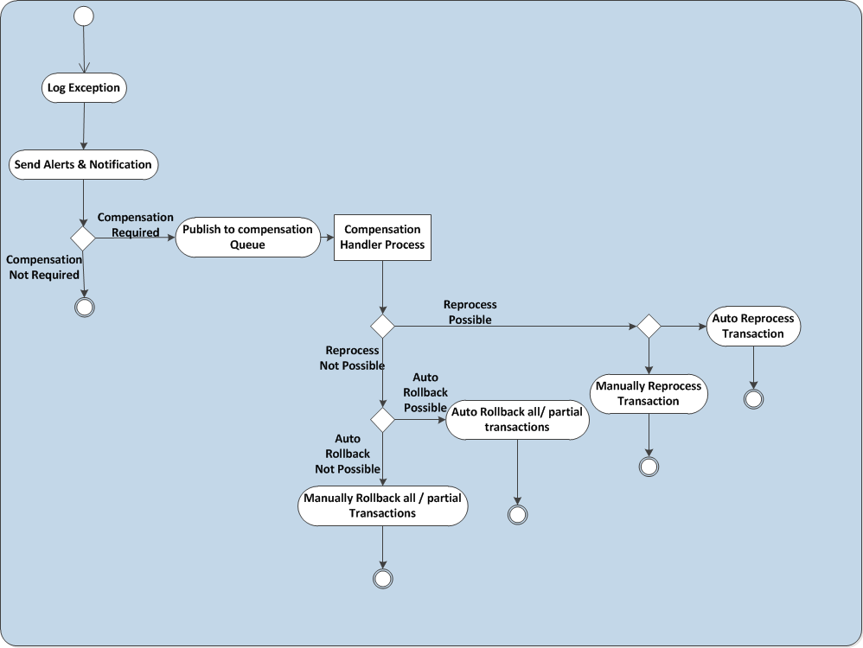
Compensation handler process would be more applicable for batch kind of transactions and transactions where we have multiple subscribers for same message.

Archiving Strategy for Exceptions & Log Data

Using Files
The recommended approach is to use efficient rollover strategy like 10 rollover files and optimized log file size i.e. 10MB. The log file name will be in a specific format defined earlier.

Volumetrics
<This section defines estimated volume of messages and transactions to be handled>

Capacity Sizing and Projection
<Provides capacity requirements based on business plans, usage trends, sizing of new services, etc>

Canonical Data Model
A canonical data model (CDM) is a type of data model that presents data entities and relationships in the simplest possible form.
It is generally used in system/database integration processes where data is exchanged between different systems, regardless of the technology used.
A canonical data model is also known as a common data model
A canonical data model primarily enables an organization to create and distribute a common definition of its entire data unit. The design of a CDM requires identifying all entities, their attributes and the relationships between them.
The importance of a CDM is particularly evident in integration processes where data units are shared between different information system platforms. It utilizes a generalized data format to present/define data that makes it simple to share data among multiple applications.

Without a CDM With CDM
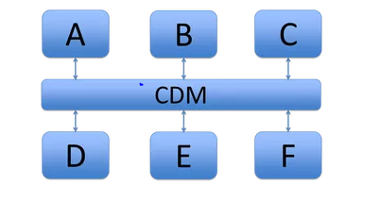
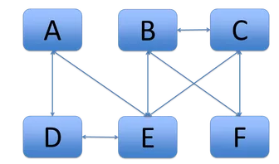

Non-Functional Requirements
NFRs may not directly impact the functionality of business systems (core transactional or enabling systems) in Enterprise. But these may have huge effect on how business system is accepted by both service consumers and providers. Once all the NFRs are defined by the project teams then it needs to be consolidated and a separate document for NFRs needs to be maintained for further Governance. In case any NFR warrants a change in the current logical/ physical Architecture then it will be discussed with the project teams and Enterprise.

Monitoring/ Logging
ML-NFR-01 | System should be able to give Hollistic view of user transaction
ML-NFR-02 | Timing information in Logging - Time taken to complete the transaction
ML-NFR-03 | Type of Requests should be logged
ML-NFR-04 | Correlation ID for each transaction should be logged - This should be system generated and include keys from canonical message
ML-NFR-05 | Logging of Performance metrics - Time taken for a transaction
ML-NFR-06 | Logging of Time taken at each component
ML-NFR-07 | Logging of Start and End Time
ML-NFR-08 | All logging and auditing should be be async
ML-NFR-09 | Logging for each transaction should be done at 3 levels - Debug, Info & Error
ML-NFR-10 | Complete Canonical XML message should be in the log message for Debug and Error
ML-NFR-11 | Partial Canonical XML message - Key fields should be in the log message for Debug and Error

Manageability

Maintainability is the ability to correct flaws in the existing functionality without impacting other components of the system. This is another of those systemic qualities that you cannot measure at the time of deployment.
MG-NFR-01 | Check the catalogue for available services and interfaces
MG-NFR-02 | Updating an existing interface/service or creating a new one

Performance
The details of the transaction volumes and the weight of the transactions are detailed in the Volumetrics. Please refer to Volumetrics section for details. Currently performance baseline needs to be established. Plan is to collect performance metrics during performance testing. These metrics will be evaluated, optimized and baselined.

Reliability
REL-NFR-01 | Reliability of the messages will be preserved by using Reliability pattern and persistent queues in VM for all applications except for Feed Services.
REL-NFR-02 | Physical queues will be in place to make the overall system more reliable and resilient except for Feed Services.

Availability
Disaster recovery is internally managed by MuleSoft CloudHub in multiple workers and in multiple zones.
AVAIL-NFR-01 | Each application will be deployed in more than one worker
AVAIL-NFR-02 | In case of any issue with the worker or zone, MuleSoft CloudHub internally manages the recovery and load balancing

Storage
STOR-NFR-01 | Caching will be done in My SQL DB and in application cache to avoid lookups
STOR-NFR-02 | Caching of all SAP lookup values will be done in My SQL and in application cache
STOR-NFR-03 | Caching of templates and other static data will be done in My SQL and in application cache

Security
SEC-NFR-01 | All Services exposed will be HTTP. There will be no additional security added on these internal services as they will be retricted via network.
SEC-NFR-02 | External DNS to CloudHub will be shutdown
SEC-NFR-03 | Restriction at the Network Level: Access will be provided from internal Enterprise network & applications tier

Other Architectural Factors

Key Decisions

Architectural Variances
Id. | Description | Owner
[Var.1]
[Var.2]
[Var. n]

Appendices

Integration Patterns High Level
Integration Pattern Name | Description | Usage | Component Diagram
Request-Reply  (Remote Invocation Pattern) | By applying the principles of encapsulation, applications are able to enter into on-demand communications where data is requested and delivered between applications. | - Multiple Applications with different languages and platforms can communicate with each other synchronously  - Pattern is used when a real time response is expected | 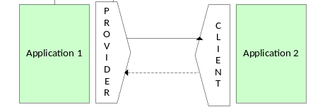
File Transfer Pattern | The File Transfer Pattern enables multiple applications to work together through the file exchange. | - Files can be XML, Fixed Width, Delimited files etc.  - Use of network shared directories or file transfer protocol (FTP) to move data files around.  - Use of industry standard schemas such as EDI. Often utilised for B2B integrations. | 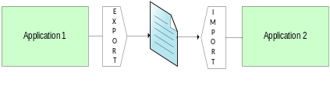
Shared Database Pattern | The Shared Database Pattern enables multiple applications to exchange information by storing the data in a single, shared database. | - Where a group of integrated applications need to share data, there can be high confidence that the data required by the applications is consistent by relying on the same database. Any write conflicts that may arise will be mitigated by the database management system.  - Common database across multiple applications (e.g. MDM) | 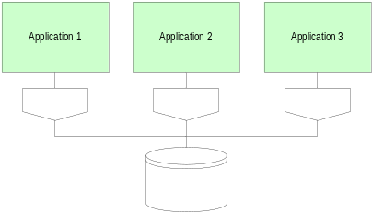
Messaging Pattern | Pattern permits the frequent and immediate exchange of data between integrated applications in a reliable, asynchronous fashion using customizable formats. | - This message pattern is well suited to event type messages corresponding to actions on business objects. These events would be published without knowledge or regard to whatever other applications are interested in them. The consumers would subscribe to the events and the business objects that they are interested in. This would effectively then trigger internal application processing accordingly.  - Guaranteed delivery is essential  - Asynchronous transfer of data with distributed systems | 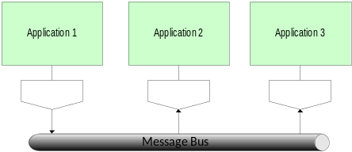

Messaging Patterns

Pattern | Sub-Pattern | Description
Service Virtualization
 | Service Proxy | Routes the request to a Proxy service and gets the response
 | Service Selector | Routes the request to a selected system using the identifier
 | Service Translator | Translates the Source request to Destination compliant format
 | Service Normalizer | Routes and Translates the request
 | Service Aggregator | Aggregates the request to multiple subsystems, collects the response and forms a single response
Message Integration
 | Message Router | Routes the request to a selected system using the identifier
 | Message Translator | Translates the Source request to Destination compliant format
 | Message Aggregator | Aggregates the request to multiple subsystems, collects the response and forms a single response
 | Message P2P | MQ Pattern for P2P integration
 | Message Correlator | Request - Response match with Correlator
 | Message Collector | Collect request messages and sends it at desired interval/count
 | Message Splitter | Splits the huge request message into pieces and sends it for processing; No WMB nodes available for Splitter pattern.
 | Message - Stored Procedure | Calls SP and sends response
Service Enablement
 | Service to MQ | A service request sends the response to MQ
 | MQ to Service | A MQ request calls the Webservice
 | Service to DB | A service request calls SP
Event Enablement
 | Database Event | Polls DB at regular intervals
 | Event Distributor | Subscribe to events; Distributes events to all subscribers
 | Event Filter | Distributes events to Subscribers for whom the filter condition is met

Message Exchange Patterns
The following sections explain various types of message exchange patterns.

Fire-and-Forget (One Way Event Handler)
The following picture depicts the generic flow of one way communication pattern through the ESB.

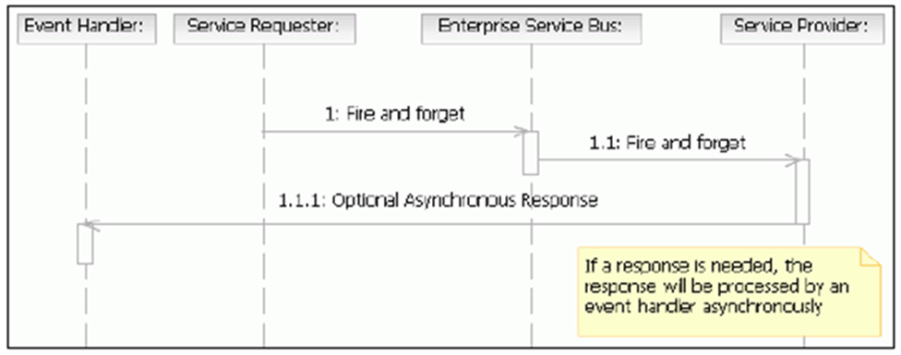

Description: In this pattern, the message exchange is one-way, sending a request to a provider. No response or fault message will be sent back to the consumer.

Business problem: Integration of two applications by the customer should not affect the sender’s application due to non-availability of the receiving application.

Pros:
Fire and forget pattern minimizes the latency for requesting application.
Guaranteed delivery can be achieved via queuing.
Asynchronous fire-and-forget allows the participating application to resume execution immediately and yield better response time to end users.

Cons:
Only used when consuming application does not need a response and loss of message can be tolerated.

Synchronous Request/Response
The following picture depicts the generic flow of request and response pattern through the ESB.

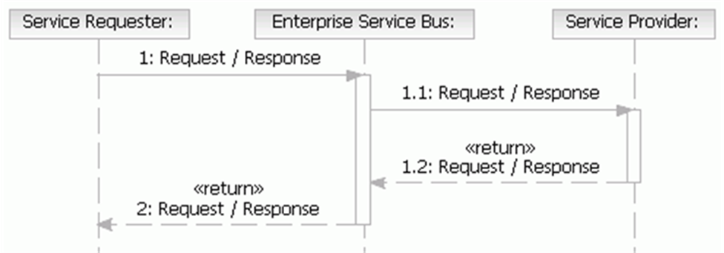
Description: In this pattern, a requestor sends a request message to a replier system, which receives and processes the request, ultimately returning a message in response. After sending the request message, the requestor waits until the service provider responds with a message or a time-out. Both the request and the response messages are independent.

Business problem: An application making a request to get information from an external system has to wait until the response is received.

Pros:
Effective for transactions requiring response in stipulated time
Synchronous interaction is for short running services / transactions like look-up service and inquiry services

Cons:
Should be used only when failure in message delivery can be accepted.
Requires high availability and better performance from provider application.
Since interaction is synchronous, consumer application needs to handle failure and re-submission of failed transactions.
Synchronicity only works if all involved services along the integration route are synchronous.

Asynchronous Request /Response (Pull)
The following picture depicts the generic flow of request and response pattern through the ESB.

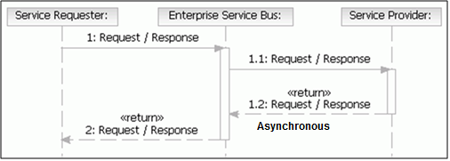
Description: A Request – Delayed Response pattern is asynchronous in nature. In this situation, the requestor sends the request message and sets up a callback for a response. The requestor will not be waiting for the response after sending the request message. A separate thread waits for response message. When the response message arrives, the response thread invokes the appropriate callback and processes the response.

Business problem: A customer integrating two applications doesn't want the sender application to be affected due to non-availability of the receiving application.

Pros:
Guaranteed Delivery ensures reliable message delivery with varying degrees of guarantees.
Robust Error Handling ensures a wide variety of errors are handled gracefully with retry / resubmission capabilities and compensation, if required.
Sequencing of messages ensures the sequence in which the messages are processed is the same as the sequence in which the messages are produced.

Cons:
Cannot be used when immediate response is required by the user.

Publish-Subscribe
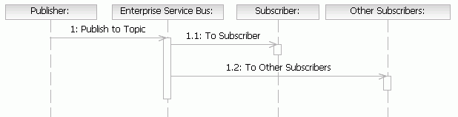
Description: There are multiple integration scenarios in which participating applications publish events and messages that are subscribed to by multiple participating applications. This pattern is transactional in the sense that changes are made to the entities in the participating applications.

Business problem: Synchronize information across multiple applications based on messages received from the Master application or messages being modified in any participating application.

Pros:
Effective for transactions requiring multiple recipients

Cons:
Cannot be used when immediate response is required by the user.

SOA Reference Architecture
The following is a brief description of the layers in the architecture.
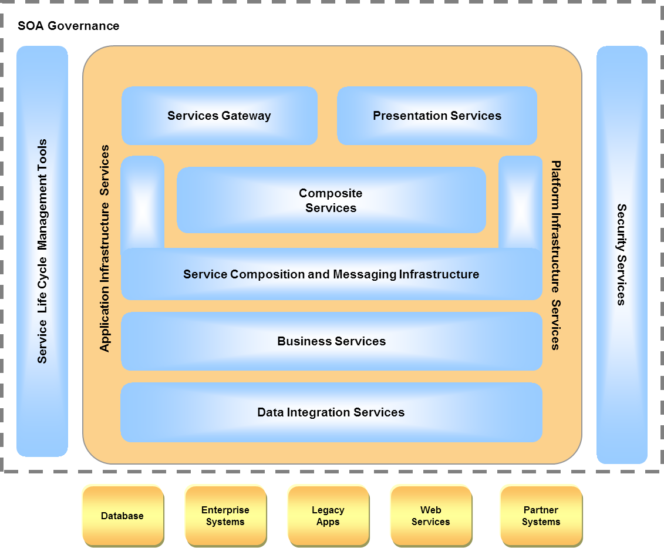
Layer | Description | Responsibilities
Services Gateway | This layer is the entry point or facade for external business partners. These have the capabilities of being deployed at the edge and form the interfacing layer to the external world and at the same time provide basic filtering, message introspection and enrichment capabilities | - Access Control  - SLA Management  - Multi-protocol Support  - Service Brokering
Presentation Services | This serves as the Presentation tier for all Business channels that access the systems. The user could be accessing the web front-end or mobile users. | - Content Delivery  - Navigation  - Branding, Internationalization & Personalization  - Collaboration  - Multi-Channel rendering
Service Composition and Messaging Infrastructure | This layer facilitates Service composition enables implementation of business processes by either a design-time or deployment-time assembly of multiple low-level, finely grained, application-oriented services. In addition, this layer provides messaging capabilities for transformation, intelligent routing rules and exception handling made available using the Messaging Infrastructure - an enterprise service bus product | - Protocol Conversion  - Brokering/Routing  - Service Callouts  - Message Translation  - Message Management  - ESB Federation
Business Services | This layer provides all the capabilities to fully realize the business process or task. Application Services expose the functionality of an application deployed as part of the business suite. Business Services are modeled around business processes and may be composed of Application Services and Infrastructure Services | - Business Services  - Application Services
Data Integration Services | This layer provides an aggregated view of all data from different sources in an enterprise and delivers this as services | - Heterogeneous Source Adaptation  - Data Mapping  - Caching  - Persistence  - Translations and Transformations  - Service Data Objects
Platform Infrastructure Services | This layer represents the runtime infrastructure that hosts all the technologies (e.g. Java EE, BPEL, BAM, ESB) and the services provided in order to enable the Services delivery | - Runtime engines/containers  - Connectors  - Utilities
Security Services | This is a set of services that ensure that the necessary security policies are applied at various security control points when a service is invoked | - Entitlements  - SSO  - Encryption  - Auditing
Services Lifecycle Management Tools | The set of tools in this layer  - Enable storage of services, service categorization and cataloguing, version management, workflow to manage the service life cycle from inception to deprecation and has capabilities to generate metrics related to the activities in the lifecycle (primarily fulfilled by a Service Repository)  - Integrate with Runtime Environment to extract usage, throughput, failure and other performance-related information for generating the business performance indicators (primarily fulfilled by Monitoring Systems) | - Service Registry  - Enterprise Repository Integration  - IDEs  - SLA Management and Tools
SOA Governance | This is the framework of processes, organization and tools for managing and monitoring the assets of the architecture and ensuring the quality level  The Services Lifecycle Management Tools form a key component of SOA Governance | - Policy Definition  - Compliance Tracking  - Control  - Measurement

